EXPERIMENT- 13
Perform Perspective Transformation on the Video
Aim
To write a Python code to perform perspective transformation on live video frames using OpenCV for changing the viewing angle of the video.
Input
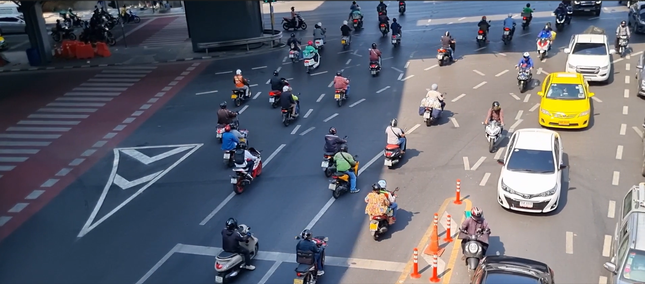
Code
import cv2
import numpy as np
cap=cv2.VideoCapture(0)
while True:
ret,frame=cap.read()
if not ret:
break
rows,cols=frame.shape[:2]
pts1=np.float32([[50,50],[200,50],[50,200],[200,200]])
pts2=np.float32([[10,100],[200,50],[100,250],[200,200]])
matrix=cv2.getPerspectiveTransform(pts1,pts2)
output=cv2.warpPerspective(frame,matrix,(cols,rows))
cv2.imshow("Perspective Video",output)
if cv2.waitKey(1)&0xFF==ord('q'):
break
cap.release()
cv2.destroyAllWindows()
Output Video
Perspective Transformed Video
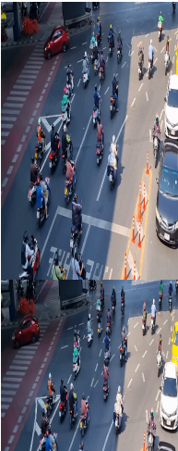
Result
Thus, perspective transformation was successfully performed on the video using OpenCV.

